  - Future Women in Science and Engineering Conference

Future Women in Science and Engineering Conference
  - Information Package

Important Highlights
Conference takes place January 10th at Queen’s University.
Early Bird registration is currently open for $20; send complete registration forms to wise@engsoc.queensu.ca
Official registration opens December 1st 2014 on the WISE website at www.queenswise.ca, for $25.
Registration includes breakfast, lunch, all workshops and prizes.
Registration closes January 1st 2015.

About FWESC
The Future Women in Science and Engineering Conference aims to introduce female high school students to the range of opportunities available in pursuing engineering and science as an academic program and future career. The conference is open to high school students in Ontario and is to be held on Saturday, January 10, 2015. The conference includes breakfast, opening remarks, keynote address, eight workshops, lunch and an open house for clubs and teams. Workshops will range from interactive presentations given by student teams and faculty members to facility tours and a student panel.
The objective of this conference is to encourage females in high school to consider engineering and science as a potential career. Activities are designed to engage students and instill confidence in their own abilities.
This event is not only beneficial to the incoming students but it is beneficial to the Queen’s students as well. Volunteers for the day will be educating the participants on the engineering program and sharing their experiences thus far. This gives our volunteers a chance to act as mentors for the participants and spark an interest in the field.

About WISE
Queen’s Women in Science and Engineering (WISE) is a non-profit, student-run organization associated with the Engineering Society and Alma Mater Society at Queen’s University. Our mandate is to form a network of students, academics and professionals in the Sciences and Engineering to foster the participation and advancement of women in these disciplines. We are able to achieve this mandate through community outreach, and events designed to support current women undergraduate students in realizing excellence in their field of interest. As women have been traditionally under-represented in the sciences and engineering, it is essential to inspire and promote a sense of community for current students, as well as for young women who are considering related degrees and careers in the future.
Our executive is composed of a President working alongside an executive body of 13 Vice-Presidents, Outreach Coordinators and Events Coordinators. Currently, WISE has 40 volunteers participating in our Outreach programs. Our Outreach programs include collaboration with the Kingston Boys and Girls Club, Girl Guides and the Winston Churchill Elementary School, as well as our EngSci Day events. For Queen’s students, executive involvement and volunteering through WISE enhances leadership skills, time-management skills, creativity, collaboration skills and community engagement. Our members and volunteers represent a diverse array of Queen’s programs, such as Life Sciences, Biology, and Geography, as well as a comprehensive variety of engineering disciplines, including students in Geology, Mining, Chemical, Physics, Mechanical, Computer and Civil Engineering.
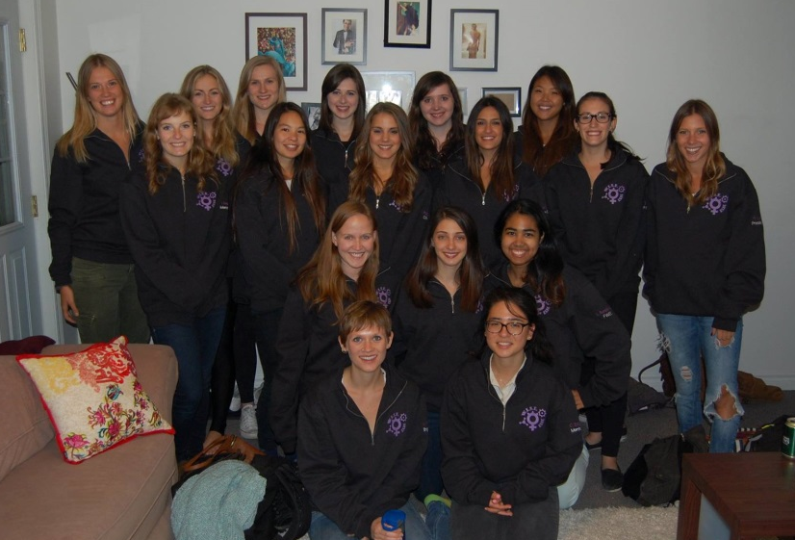

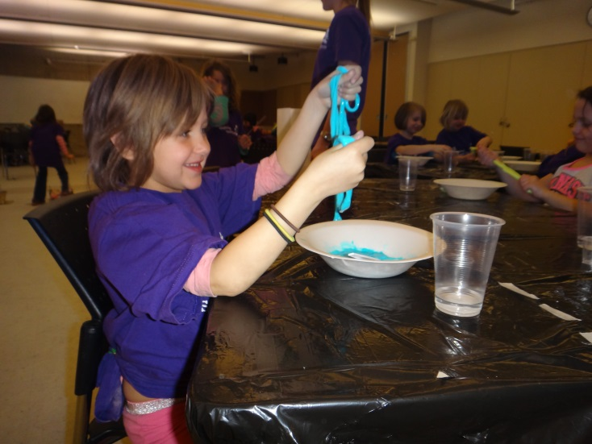

Why should I send my daughter or student to FWESC?:
FWESC aims to create a positive image and idea of science and engineering for young female students in hopes that this encouragement will change the stigma attached to some university programs such as science and engineering. Long gone are the days of the stereotypical scientist, today students from all disciplines lead balanced lives that span far beyond the classroom and FWESC hopes to showcase just this during the conference. Our slogan for FWESC 2015 is “Stop the Stigma”, a degree in science or engineering is an attainable post-secondary goal for all students and by promoting this event to your students you could play an important role in helping them achieve this goal.

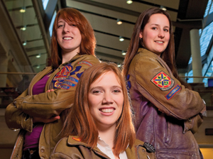

A Word from our Coordinators

Dear Prospective FWESC Delegate,
Allow me to start off by saying thank you for your interest in our conference and tell you how excited I am for the event to be so quickly approaching. I am a fourth year Chemical Engineering and Economics student here at Queens University and one of the co-coordinators for the Future Women in Science and Engineering Conference for the 2014-2015 academic year.
Having been involved in the conference since the idea was sparked in 2013 I could not be more appreciative in the effort put in by so many member of WISE and the Queens community that is needed to run an event of this type. Speaking as a female engineering student, I wish that I had access to a conference like this when I was in high school and looking into my options for post-secondary education. For this reason I encourage all interested students to come to the conference and learn what a degree in science or engineering has to offer you.
Not only do these degrees provide concrete knowledge in certain subjects that could be later applied to a professional position, they offer the opportunity for students to grow socially, intellectually and personally by challenging them in different ways. I hope that with this event and many others like it we can break the stigma of the typical “engineer” or “scientist” and educate young women on what those terms really mean.
During my time at Queens and throughout my degree in engineering I have had the chance to experience different things ranging from an internship position in Montreal to an academic exchange where I spent 5 months studying in Australia. The world of science and engineering is growing and changing rapidly, as are the students who study them; FWESC hopes to shed light on areas of these programs that students may have otherwise not been aware of.
Thank you once again for your interest in our conference; I hope to see you all there!

Taylor Wilson-Sipkema
Future Women in Science and Engineering Coordinator, WISE Queens Chapter
Bachelor of Science in Chemical Engineering Candidate, Queens University 2015
Bachelor of Arts in Economics Candidate, Queens University 2016

A word from the Coordinators

Hello Prospective FWESC Delegate,
I'm a 3rd year civil engineering student at Queen's hoping to specialize in structural engineering. Right now, my goal for the future is to enter the structural consulting industry to work on aging buildings. When I was in grade 12, I applied to 9 different programs and had no idea what I wanted to study.
In high school, the courses I enjoyed were math, leadership, and some parts of the sciences. I wasn't sure at all where to go with that and I often wonder how I ended up in engineering. But now, I definitely couldn't imagine myself studying anything else!
The reason I got into engineering is why I think FWESC is so important. For whatever reason, engineering doesn't seem to be an automatic consideration for girls in high school. FWESC aims to encourage girls to consider science and engineering and to pursue their interests in them!
We want to bring the missing information about undergraduate degrees in science and engineering to high school students. At FWESC, students will have the opportunity to experience many aspects of science and engineering in a university environment. They will also be able to interact with current university students of varying streams of study to really get to understand what a degree is science or engineering is about.
We would like to dispel some common misconceptions and help students learn about possible futures in science and engineering!

Lily Sundararaj
Future Women in Science and Engineering Coordinator, WISE Queens Chapter
Bachelor of Science in Civil Engineering Candidate, Queens University 2016

Additional Information

How to Sign up
Early Bird registration is currently open to delegates at a discounted price of $20; delegates interested in registering for the early bird deadline can fill out the registration form and send it to wise@engsoc.queensu.ca
Official registration opens on December 1st 2014 and will be available on the WISE website at www.queenswise.ca, the delegate fee after December 1st will be $25 per student which includes breakfast, lunch, all workshops and prizes. Registration will close on January 1st 2015 and the conference will take place on January 10th 2015.

Event Location

The event will be taking place at Robert Sutherland Hall on the Queens University campus in Kingston, Ontario. See the image below for the location Robert Sutherland Hall (in red) on the Queen’s Campus.

Registration Form
Name:
Phone number:
Age:
Grade:
High school:
Interested field of study:
What made you want to apply to FWESC:

Allergies:

Mailing address:

Emergency contact information:
Email address:
Name of teacher sponsor (any teacher that helped or directed you to the conference):

We look forward to seeing you!

